To calculate the probability of gain higher than 2% or more, we need to find out what is the sum of all probabilities that gain can take values more than 0.02 (i.e., 2%).

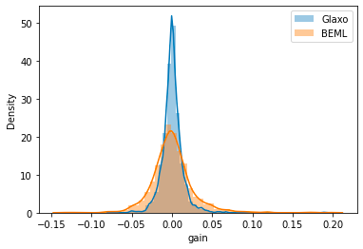Probability of making

2% loss or higher in Glaxo: 0.063 or 6.3%

Probability of making

2% loss or higher in BEML: 0.2215 or 22.3%

Probability of making

2% gain or higher in Glaxo: 0.0710 or 7.1%

Probability of making

2% gain or higher in BEML: 0.2276 or 22.76%